Sets types
# Source: AI Source: Provided by: [Data Path: Persons Table -> ID Column: 1, Name_En Column: Motasem Essam] -> From: [ChatGPT] on [7/7/2026]
Set types refer to different kinds of sets based on their properties and elements:
Single Set
- Finite Set
- Infinite Set
- Null Set (Empty Set)
- Singleton Set
- Power Set
- Universal Set
Two sets
- Disjoint Sets
- Equivalent Sets
- Equal Sets
- Unequal Sets

Single Set

1. Finite Set
# Source: AI Source: Provided by: [Data Path: Persons Table -> ID Column: 1, Name_En Column: Motasem Essam] -> From: [ChatGPT] on [7/7/2026]

A finite set is a set that contains a limited number of elements. In other words, it has a countable number of elements that can be enumerated or listed. The number of elements in a finite set is a natural number, meaning it can be 0, 1, 2, and so on.

Properties of finite sets
# Source: AI Source: Provided by: [Data Path: Persons Table -> ID Column: 1, Name_En Column: Motasem Essam] -> From: [ChatGPT] on [7/7/2026]
Cardinality: The number of elements in a finite set is called the cardinality of the set. For example, the set {1,2,3} has a cardinality of 3.
Subsets: Any subset of a finite set is also finite.
Union and Intersection: The union and intersection of finite sets will also be finite.

A finite set contrasts with an infinite set, which has an unlimited number of elements (e.g., the set of all natural numbers N.

Examples of finite sets
# Source: AI Source: Provided by: [Data Path: Persons Table -> ID Column: 1, Name_En Column: Motasem Essam] -> From: [ChatGPT] on [7/7/2026]
- The set of natural numbers less than 5: A={1,2,3,4} (4 elements).
- The set of vowels in the English alphabet: B={a,e,i,o,u} (5 elements).
- The set of primary colors: C={red,blue,yellow} (3 elements).

Importance in Mathematics
# Source: AI Source: Provided by: [Data Path: Persons Table -> ID Column: 1, Name_En Column: Motasem Essam] -> From: [ChatGPT] on [7/7/2026]
Finite sets are essential in mathematics as they form the foundation of set theory and appear in numerous applications:
- Set Theory: They help define concepts like cardinality and subsets.
- Combinatorics: Central to counting, permutations, and combinations.
- Algebra: Key in studying finite groups and fields, crucial for cryptography and coding theory.
- Discrete Mathematics: Used in graph theory, algorithms, and finite automata.
- Applications: Found in probability, statistics, data structures, and optimization.
- Education: Ideal for teaching fundamental mathematical reasoning.
Their simplicity and versatility make them vital across both theoretical and practical domains.

2. Infinite Set
# Source: AI Source: Provided by: [Data Path: Persons Table -> ID Column: 1, Name_En Column: Motasem Essam] -> From: [ChatGPT] on [7/7/2026]
An infinite set is a set that contains an uncountable or limitless number of elements. This is in contrast to a finite set, which has a definite number of elements.

Infinite sets Types
# Source: AI Source: Provided by: [Data Path: Persons Table -> ID Column: 1, Name_En Column: Motasem Essam] -> From: [ChatGPT] on [7/7/2026]
Infinite sets can be classified into two types:
- Countably Infinite Set: A set is countably infinite if its elements can be put into a one-to-one correspondence with the set of natural numbers (i.e., the set can be "counted" despite having an infinite number of elements). Examples of countably infinite sets include:
  - The set of natural numbers N={1,2,3,4,5,… }.
  - The set of integers Z={…,−2,−1,0,1,2,… }.
  - The set of rational numbers Q can also be countably infinite, even though it seems vast.
- Uncountably Infinite Set: A set is uncountably infinite if there is no way to list its elements in a sequence that corresponds to the natural numbers. The elements are so numerous that they cannot be matched with the natural numbers. An example of an uncountably infinite set is:
  - The set of real numbers R. The real numbers between any two points (like 0 and 1) form an uncountably infinite set, meaning it is not possible to "list" all real numbers in a sequence.

Properties of Infinite Sets
# Source: AI Source: Provided by: [Data Path: Persons Table -> ID Column: 1, Name_En Column: Motasem Essam] -> From: [ChatGPT] on [7/7/2026]
- Cardinality: The "size" or cardinality of a set can be compared using concepts like countable and uncountable. A set is countably infinite if it can be paired with the natural numbers, and uncountably infinite if it cannot.
- Subset: An infinite set can have a subset that is also infinite. For example, the set of even numbers {2,4,6,8,… } is a subset of the set of natural numbers {1,2,3,4,5,… }, and both are countably infinite.

Examples of infinite sets
# Source: AI Source: Provided by: [Data Path: Persons Table -> ID Column: 1, Name_En Column: Motasem Essam] -> From: [ChatGPT] on [7/7/2026]
- Set of real numbers (Uncountably Infinite): R={−1.5,0,1,2,π,e,… } The set of real numbers is infinite and uncountable. There is no way to list all real numbers in a sequence. For example, between 0 and 1, there are infinitely many real numbers.
- Set of even numbers (Countably Infinite): {2,4,6,8,10,… } This set is infinite and countable, as we can list the even numbers in a sequence.
- Set of odd numbers (Countably Infinite): {1,3,5,7,9,… }} Like the set of even numbers, the set of odd numbers is countably infinite.
- Set of prime numbers (Countably Infinite): {2,3,5,7,11,13,17,… } The set of prime numbers is infinite because there are infinitely many primes, and it is countably infinite.
- Set of points on the interval [0, 1] (Uncountably Infinite): [0,1]={x∣0≤x≤1} The points in this interval form an uncountably infinite set, meaning there is no way to list all the points between 0 and 1. There are infinitely many real numbers in this range.
- Set of complex numbers (uncountably infinite): C={a+bi∣a,b∈R} The set of all complex numbers is infinite because both the real and imaginary parts can take infinitely many values. The set of complex numbers, C, is an uncountably infinite set, as it has the same cardinality as the real numbers R, which is strictly greater than the cardinality of any countably infinite set like N. Therefore, the complex numbers cannot be listed in a sequence or paired one-to-one with the natural numbers.
- Set of algebraic numbers (Countably Infinite) (numbers that are roots of polynomial equations with integer coefficients): {2,12,−3,… } The set of algebraic numbers is infinite and countably infinite because we can list these numbers, even though they are not all rational.

Importance in Mathematics
# Source: AI Source: Provided by: [Data Path: Persons Table -> ID Column: 1, Name_En Column: Motasem Essam] -> From: [ChatGPT] on [7/7/2026]
Infinite sets are vital in mathematics for advancing concepts of infinity and continuity, with key importance in:
- Set Theory: They introduce infinite cardinalities (e.g., countable vs. uncountable).
- Analysis: Essential for limits, continuity, and infinite sequences.
- Topology: Form the basis of open, closed, and connected spaces.
- Algebra: Studied in infinite groups, fields, and vector spaces.
- Logic: Foundational in exploring paradoxes and formal proof systems.
- Measure Theory: Enable advanced geometry and integration.
- Applications: Model time, space, and data in physics and computer science.
- Philosophy: Encourage exploration of infinity and its implications.

3. Null Set (Empty Set)
# Source: AI Source: Provided by: [Data Path: Persons Table -> ID Column: 1, Name_En Column: Motasem Essam] -> From: [ChatGPT] on [7/7/2026]
The null set (or empty set) is a set with no elements. It is denoted by:
- ∅ (a special symbol for the empty set), or
- {} (a pair of curly braces with nothing inside).
- For example: {} or ∅

Key Properties
# Source: AI Source: Provided by: [Data Path: Persons Table -> ID Column: 1, Name_En Column: Motasem Essam] -> From: [ChatGPT] on [7/7/2026]
1-No Elements:
- The defining characteristic of the null set is that it contains no elements.
- For any element x, it is not true that x∈∅.
2-Subset of Every Set:
- The empty set is a subset of every set A: ∅⊆A This is because the condition for being a subset (x∈∅ ⟹ x∈A) is vacuously true since x∈∅ is never true.
3-Unique:
- There is only one empty set in mathematics. Even if you think of it differently (e.g., as "the set of even numbers less than 1"), it is still the same empty set.
4-Cardinality:
- The number of elements in the null set is zero: ∣∅∣=0|

Examples
# Source: AI Source: Provided by: [Data Path: Persons Table -> ID Column: 1, Name_En Column: Motasem Essam] -> From: [ChatGPT] on [7/7/2026]
- The set of natural numbers less than 0:
{x∈N∣x<0}=∅
- The set of solutions to the equation x²+1=0 (in real numbers):
{x∈R∣x²+1=0}=∅
(There are no real numbers that satisfy x²+1=0.)
- The intersection of two disjoint sets:
A={1,2},B={3,4} ⟹ A∩B=∅

Importance in Mathematics
# Source: AI Source: Provided by: [Data Path: Persons Table -> ID Column: 1, Name_En Column: Motasem Essam] -> From: [ChatGPT] on [7/7/2026]
The null set (empty set, ∅\emptyset∅) is crucial in mathematics due to its foundational role:
- Set Theory: Serves as the basis for defining all sets and is the unique set with zero elements.
- Logic: Represents "nothing," aiding in formal proofs and logical consistency.
- Subset Property: Every set includes the null set as a subset, essential in defining power sets.
- Algebra and Functions: Helps identify empty solutions in equations or systems with no valid outcomes.
- Topology: Acts as a necessary element in defining open and closed sets.
- Measure Theory: Has a measure of zero, crucial for integration and probability.
The null set is fundamental for building mathematical structures and ensuring logical coherence.

4. Singleton Set
# Source: AI Source: Provided by: [Data Path: Persons Table -> ID Column: 1, Name_En Column: Motasem Essam] -> From: [ChatGPT] on [7/7/2026]
A singleton set is a set with exactly one element. For example:
S={a}
Here:
- S is the singleton set.
- a is the only element in the set.
The key property of a singleton set is that its cardinality (number of elements) is 1.

Key Properties
# Source: AI Source: Provided by: [Data Path: Persons Table -> ID Column: 1, Name_En Column: Motasem Essam] -> From: [ChatGPT] on [7/7/2026]
- Cardinality:
  - The number of elements in a singleton set is always 1: ∣S∣=1
- Subsets:
  - A singleton set S={a} has two subsets:
    - The empty set: ∅
    - The set itself: {a}
- Unique Element:
  - In a singleton set, there is exactly one element. No other elements can exist in the set.
- Relation to Functions:
  - A function from any set to a singleton set is trivial because all elements of the domain are mapped to the single element of the singleton set.
Note:
Trivial: In mathematics, "trivial" often refers to situations where:
1-There is no complexity or interesting structure to analyze.
2-The outcome is predictable and straightforward.
For functions from a set to a singleton set, the lack of choice (only one output for all inputs) makes these functions trivial.

Examples
# Source: AI Source: Provided by: [Data Path: Persons Table -> ID Column: 1, Name_En Column: Motasem Essam] -> From: [ChatGPT] on [7/7/2026]
- The set containing the number 5:
S={5}
- The set containing the string "Hello":
T={"Hello"}
- The set containing an empty set (this is an important example in set theory):
U={∅}
Here, the element of U is the empty set ∅, making U a singleton set.

Importance in Mathematics
# Source: AI Source: Provided by: [Data Path: Persons Table -> ID Column: 1, Name_En Column: Motasem Essam] -> From: [ChatGPT] on [7/7/2026]
A singleton set (a set with exactly one element) is important in mathematics due to its foundational role:
- Set Theory: Simplest example of finite sets, aiding in understanding cardinality.
- Logic: Represents unique elements, crucial in formal proofs and reasoning.
- Topology: In some spaces, singleton sets are closed; they help study separation and continuity.
- Functions: Used to define constant functions where the domain maps to a single element.
- Algebra: Forms trivial substructures like single-element groups or ideals.
Singleton sets bridge individual elements and larger collections, serving as a building block for mathematical structures.

5. Power Set
# Source: AI Source: Provided by: [Data Path: Persons Table -> ID Column: 1, Name_En Column: Motasem Essam] -> From: [ChatGPT] on [7/7/2026]
Definition: The power set of a set A is the set of all possible subsets of A, including the empty set and A itself.
or
The subsets of a set A are all possible combinations of the elements in A, including the empty set and the set A itself.

- The power set of A is denoted as: P(A)
- It is defined as: P(A)={S∣S⊆A} Here, S represents every possible subset of A.

- Example: If A={1,2}, then the power set of A is {∅, {1}, {2}, {1,2}}.
- P(A)={x∣x⊆A}
- Example: For S={1,2,3},
the subsets are:
- The empty set: ∅
- All subsets with one element: {1},{2},{3}
- All subsets with two elements: {1,2},{1,3},{2,3}
- The subset with all elements: {1,2,3}
Thus, the total set of subsets is:
{∅,{1},{2},{3},{1,2},{1,3},{2,3},{1,2,3}}
This includes all combinations of the elements of S, from the empty set (no elements) to the full set. There are 2³=8 subsets for a set of 3 elements.

Cardinality
# Source: AI Source: Provided by: [Data Path: Persons Table -> ID Column: 1, Name_En Column: Motasem Essam] -> From: [ChatGPT] on [7/7/2026]
If A has n elements, the power set P(A) has 2^{n} elements.

Calculate number of subsets
# Source: AI Source: Provided by: [Data Path: Persons Table -> ID Column: 1, Name_En Column: Motasem Essam] -> From: [ChatGPT] on [7/7/2026]
To calculate the number of subsets of a set, you can use a simple formula:

Formula
# Source: AI Source: Provided by: [Data Path: Persons Table -> ID Column: 1, Name_En Column: Motasem Essam] -> From: [ChatGPT] on [7/7/2026]
For a set with n elements, the number of subsets (including the empty set and the set itself) is given by:
Number of subsets=2^{n}
Where:
- n is the number of elements in the set.

Explanation
# Source: AI Source: Provided by: [Data Path: Persons Table -> ID Column: 1, Name_En Column: Motasem Essam] -> From: [ChatGPT] on [7/7/2026]
Each element of the set can either be included in or excluded from a subset. Therefore, for each of the n elements, there are 2 choices: include the element or exclude it.
Since there are n elements and each element has 2 choices (included or not), the total number of subsets is 2^{n}.

Example
# Source: AI Source: Provided by: [Data Path: Persons Table -> ID Column: 1, Name_En Column: Motasem Essam] -> From: [ChatGPT] on [7/7/2026]
For the set S={1,2,3}, it has 3 elements, so:
Number of subsets=2³=8
The subsets of S={1,2,3} are:
{∅,{1},{2},{3},{1,2},{1,3},{2,3},{1,2,3}}
Thus, there are 8 subsets.

General Rule
# Source: AI Source: Provided by: [Data Path: Persons Table -> ID Column: 1, Name_En Column: Motasem Essam] -> From: [ChatGPT] on [7/7/2026]
For any set S with n elements:
- If n=0 (the empty set), then the number of subsets is 2⁰=1 (just the empty set).
- If n=1, then the number of subsets is 2¹=2 (the empty set and the set itself).
- For larger sets, the number of subsets grows exponentially as 2^{n}.

Conclusion
# Source: AI Source: Provided by: [Data Path: Persons Table -> ID Column: 1, Name_En Column: Motasem Essam] -> From: [ChatGPT] on [7/7/2026]
The formula 2^{n} efficiently calculates the number of subsets for a set of size n.

Examples
# Source: AI Source: Provided by: [Data Path: Persons Table -> ID Column: 1, Name_En Column: Motasem Essam] -> From: [ChatGPT] on [7/7/2026]
For A={1,2}:
- Subsets: ∅,{1},{2},{1,2}
- Power set: P(A)={∅,{1},{2},{1,2}}

Importance in Mathematics
# Source: AI Source: Provided by: [Data Path: Persons Table -> ID Column: 1, Name_En Column: Motasem Essam] -> From: [ChatGPT] on [7/7/2026]
1-Set Theory: Forms the basis for studying subsets and relationships between sets.
2-Logic: Represents all possible outcomes or scenarios in propositional logic.
3-Mathematics and CS: Used in combinatorics, probability, and database queries.
4-Topology: Helps define product spaces and other advanced concepts.

The power set plays a fundamental role in understanding and manipulating sets.

6. Universal Set
# Source: AI Source: Provided by: [Data Path: Persons Table -> ID Column: 1, Name_En Column: Motasem Essam] -> From: [ChatGPT] on [7/7/2026]
The universal set is a set that contains all the elements under consideration for a particular discussion or problem, Every other set in that context is a subset of the universal set,
It is typically denoted by U.

Definition
# Source: AI Source: Provided by: [Data Path: Persons Table -> ID Column: 1, Name_En Column: Motasem Essam] -> From: [ChatGPT] on [7/7/2026]
- The universal set serves as the "universe" for a specific context, including all possible elements of interest.
- All other sets being discussed are subsets of the universal set.

Properties
# Source: AI Source: Provided by: [Data Path: Persons Table -> ID Column: 1, Name_En Column: Motasem Essam] -> From: [ChatGPT] on [7/7/2026]
1-Contains All Subsets: Every set being considered is a subset of U.
2-Complement: The complement of a set A (elements in U but not in A) is defined relative to U.

Examples
# Source: AI Source: Provided by: [Data Path: Persons Table -> ID Column: 1, Name_En Column: Motasem Essam] -> From: [ChatGPT] on [7/7/2026]
1-For a discussion involving natural numbers: U=N.
2-For a survey of students in a class: U includes all students in that class.
3-In geometry: U might be the set of all points in a plane.

A set which consists of all elements of other sets present in a Venn diagram.Example: A={1,2}, B={2,3}, The universal set here will be, U = {1, 2,3}
- Example: If we are discussing or considering the set of natural numbers, the universal set could be U={1,2,3,4,…}.

Importance in Mathematics
# Source: AI Source: Provided by: [Data Path: Persons Table -> ID Column: 1, Name_En Column: Motasem Essam] -> From: [ChatGPT] on [7/7/2026]
1-Set Theory: Provides a reference for operations like union, intersection, and complement.
2-Logic: Useful in universal quantification and Venn diagrams.
3-Applications: Common in probability, databases, and real-world classifications.
The universal set is context-dependent, changing based on the problem or domain of study.

Two sets

1. Disjoint Sets
# Source: AI Source: Provided by: [Data Path: Persons Table -> ID Column: 1, Name_En Column: Motasem Essam] -> From: [ChatGPT] on [7/7/2026]
Disjoint sets are two or more sets that have no elements in common. Formally, sets A and BBB are disjoint if their intersection is the null set (A∩B=∅).

Key Characteristics
# Source: AI Source: Provided by: [Data Path: Persons Table -> ID Column: 1, Name_En Column: Motasem Essam] -> From: [ChatGPT] on [7/7/2026]
1-No Common Elements: Disjoint sets have completely distinct elements.
- Example: A={1,2,3}, B={4,5,6}; A∩B=∅.
2-Intersection is Empty: The only possible intersection between disjoint sets is the empty set (∅).
- Example: For A={Cats, Dogs} and B={Birds, Fish}, A∩B=∅.
3-Mutually Exclusive: Disjoint sets are non-overlapping and do not share any elements.
- Example: The set of odd numbers and the set of even numbers are disjoint.

Examples of Disjoint Sets
# Source: AI Source: Provided by: [Data Path: Persons Table -> ID Column: 1, Name_En Column: Motasem Essam] -> From: [ChatGPT] on [7/7/2026]
Real-World Contexts:
- A={Teachers}, B={Students}.
- A={Cars}, B={Bicycles}.
Mathematical Contexts:
- A={1,3,5}, B={2,4,6}.
- A={Prime Numbers}, B={Composite Numbers}.

Representation
# Source: AI Source: Provided by: [Data Path: Persons Table -> ID Column: 1, Name_En Column: Motasem Essam] -> From: [ChatGPT] on [7/7/2026]
- Venn Diagrams: Non-overlapping circles in a Venn diagram visually represent disjoint sets.
- Algebraic Form: A∩B=∅A \cap B = \emptysetA∩B=∅, showing the absence of common elements.

Applications of Disjoint Sets
# Source: AI Source: Provided by: [Data Path: Persons Table -> ID Column: 1, Name_En Column: Motasem Essam] -> From: [ChatGPT] on [7/7/2026]
- Data Categorization: Grouping items into mutually exclusive categories.
  - Example: Male and female athletes in a competition.
- Error Detection: Ensuring no overlap in classification.
  - Example: Disjoint partitions of network traffic (secure vs. unsecure).
- Set Theory and Logic: Used in proofs, algorithms, and mathematical analysis.
Disjoint sets ensure clarity and distinction between groups, both in theoretical and practical scenarios.

Importance in Mathematics
# Source: AI Source: Provided by: [Data Path: Persons Table -> ID Column: 1, Name_En Column: Motasem Essam] -> From: [ChatGPT] on [7/7/2026]
1. Distinct Classification
- Disjoint sets ensure elements are categorized without overlap, making them useful for defining mutually exclusive groups.
  - Example: Separating odd and even numbers.
2. Basis for Set Theory
- Disjoint sets are foundational in set theory for understanding relationships between sets.
  - Example: Partitioning a universal set into non-overlapping subsets

3. Applications in Probability
- Disjoint (mutually exclusive) events are central to calculating probabilities.
  - Example: Rolling a die where A={1, 3, 5} (odd numbers) and B={2, 4, 6} (even numbers).
4. Simplifies Mathematical Analysis
- Disjoint sets simplify computations and problem-solving by removing overlap.
  - Example: Dividing data into disjoint intervals for integration.
5. Graph Theory and Algorithms
- Used in algorithms like disjoint-set data structures to solve problems in graph theory, such as finding connected components.
  - Example: Union-Find algorithm in Kruskal’s minimum spanning tree.
6. Logical Consistency
- Ensures logical separation in proofs and problem setups.
  - Example: Proving the non-overlap of complementary angles in different quadrants.
7. Partitioning and Decomposition
- Any set can be partitioned into disjoint subsets, aiding in decomposition problems.
  - Example: Dividing students into distinct groups for activities.
8. Real-World Applications
- Used in practical scenarios like resource allocation, classification, and conflict resolution.
  - Example: Assigning non-overlapping tasks to workers.

Disjoint sets are integral to mathematical structures, providing clarity, precision, and efficiency in theoretical and practical applications.

2. Equivalent Sets
# Source: AI Source: Provided by: [Data Path: Persons Table -> ID Column: 1, Name_En Column: Motasem Essam] -> From: [ChatGPT] on [7/7/2026]
Equivalent sets are sets that have the same number of elements (cardinality) ∣A∣=∣B∣, regardless of what the elements are. If two sets A and B have the same number of elements, they are said to be equivalent, denoted as:
A∼B or A≡B

Key Characteristics of Equivalent Sets
# Source: AI Source: Provided by: [Data Path: Persons Table -> ID Column: 1, Name_En Column: Motasem Essam] -> From: [ChatGPT] on [7/7/2026]
1-Equal Cardinality:
Two sets are equivalent if their cardinalities are the same.
- Example: A={1,2,3}, B={x,y,z} → ∣A∣=∣B∣=3.
2-No Dependency on Elements:
The actual elements of the sets do not matter, only their count does.
- Example: A={Apple, Banana, Cherry}, B={Car, Bus, Train} → Both have 3 elements.
3-Unordered Elements:
Sets do not need to have elements in the same order to be equivalent.
- Example: A={a,b,c}, B={c,b,a}.
4-Different Types of Elements Allowed:
Sets with completely different types of elements can still be equivalent if their sizes match.
- Example: A={Dog, Cat, Bird}, B={1,2,3}.
5-Finite and Infinite Sets:
Both finite and infinite sets can be equivalent, as long as their cardinalities are the same.

Examples of Equivalent Sets:
- Example: A={All integers}A, B={All even integers} → Both are infinite and equivalent.
- Example: If A={1,2,3} and B={a,b,c}, then A≡B because both sets have three elements.

Importance of Equivalent Sets
# Source: AI Source: Provided by: [Data Path: Persons Table -> ID Column: 1, Name_En Column: Motasem Essam] -> From: [ChatGPT] on [7/7/2026]
1-Comparison of Data: Useful for comparing the size of datasets or groups.
2-Mapping Relationships: Helps in establishing one-to-one correspondences.
3-Logical Reasoning: Used in proofs and problem-solving in set theory.
4-Resource Allocation: Ensures equal distribution of resources in real-life situations.
Equivalent sets simplify the comparison and understanding of groups or collections with a focus on their size.

3. Equal Sets
# Source: AI Source: Provided by: [Data Path: Persons Table -> ID Column: 1, Name_En Column: Motasem Essam] -> From: [ChatGPT] on [7/7/2026]
Two sets are considered equal sets if they have exactly the same elements, regardless of the order or repetition of those elements. Equal sets are denoted as: A=B
This means that every element of set A is also an element of set B, and vice versa.

Key Characteristics of Equal Sets
# Source: AI Source: Provided by: [Data Path: Persons Table -> ID Column: 1, Name_En Column: Motasem Essam] -> From: [ChatGPT] on [7/7/2026]
1-Same Elements:
- The sets must have identical elements.
- Example: A={1,2,3}, B={3,2,1}.
2-Order Doesn’t Matter:
- The sequence of elements in the sets does not affect equality.
- Example: A={apple, banana, cherry}, B={banana, cherry, apple}.
3-Repetition Doesn’t Matter:
- Repeated elements are treated as a single instance.
- Example: A={1,1,2,3}, B={1,2,3}.
4-Cardinality is Equal:
- Equal sets have the same number of elements because their elements are identical.
- Example: A={x,y,z}, B={z,y,x}.
5-Subset Relationship:
- For A=B=, it must be true that A⊆B= and B⊆A.

Examples of Equal Sets
# Source: AI Source: Provided by: [Data Path: Persons Table -> ID Column: 1, Name_En Column: Motasem Essam] -> From: [ChatGPT] on [7/7/2026]
1-Days of the Week:
- A={Monday, Tuesday, Wednesday}
- B={Tuesday, Wednesday, Monday}
- A=B, as they contain the same elements.
2-Set of Prime Numbers:
- A={2,3,5}, B={3,5,2}
- A=B, because they have the same prime numbers.
3-Students in Two Groups:
- A={John, Mary, Ali}, B={Mary, Ali, John}
- The groups are equal as the same students are in both.

4-Fruit Basket:
- A={Apple, Orange, Banana}, B={Banana, Orange, Apple}
- Both baskets contain the same fruits, so A=B.

Difference Between Equivalent and Equal Sets
# Source: AI Source: Provided by: [Data Path: Persons Table -> ID Column: 1, Name_En Column: Motasem Essam] -> From: [ChatGPT] on [7/7/2026]
1-Equivalent Sets: Same cardinality but not necessarily identical elements.
- Example: A={1,2,3}, B={x,y,z}.
2-Equal Sets: Same elements and cardinality.
- Example: A={1,2,3, B={1,2,3}.
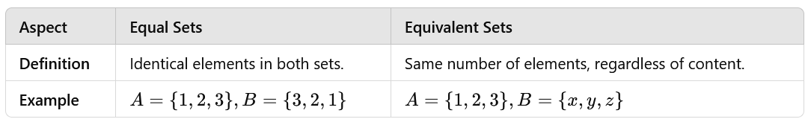

Importance of Equal Sets
# Source: AI Source: Provided by: [Data Path: Persons Table -> ID Column: 1, Name_En Column: Motasem Essam] -> From: [ChatGPT] on [7/7/2026]
- Logical Clarity:
  - Ensures unambiguous comparisons between groups.
- Data Validation:
  - Useful for verifying if two datasets or collections are identical.
- Set Operations:
  - Fundamental in mathematical proofs and operations in set theory.
- Real-World Applications:
  - Matching identical records, verifying results, or ensuring consistency.
Equal sets are a foundational concept in mathematics and set theory, providing a precise way to determine identical collections of elements.

4. Unequal Sets
# Source: AI Source: Provided by: [Data Path: Persons Table -> ID Column: 1, Name_En Column: Motasem Essam] -> From: [ChatGPT] on [7/7/2026]
Two sets are considered unequal sets if they do not contain exactly the same elements. This occurs when:
- At least one element in one set is missing from the other.
- The sets have different sizes (cardinalities).
In mathematical notation, for two sets A and B:
A≠B
This means there exists at least one element that is in A but not in B, or vice versa.

Two sets are unequal if they have at least one other element.
- Example: let X = { 2, 5 , 6, 8 } and Y = { 6, 2, 4, 8}, then X and Y are unequal sets.

Key Characteristics of Unequal Sets
# Source: AI Source: Provided by: [Data Path: Persons Table -> ID Column: 1, Name_En Column: Motasem Essam] -> From: [ChatGPT] on [7/7/2026]
1-Different Elements:
- At least one element in A is not in B, or vice versa.
- Example: A={1,2,3}, B={1,2,4}.
2-Different Cardinalities:
- If the number of elements in A differs from the number of elements in B, the sets are unequal.
- Example: A={1,2,3}, B={1,2}.
3-Order Doesn’t Matter:
- Unequal sets depend on content, not order.
- Example: A={a,b,c}, B={a,c,d}.
4-Subset Relationship is Not Bidirectional:
- A⊆B or B⊆A without equality implies A≠B.
- Example: A={1,2},B={1,2,3}.

Examples of Unequal Sets
# Source: AI Source: Provided by: [Data Path: Persons Table -> ID Column: 1, Name_En Column: Motasem Essam] -> From: [ChatGPT] on [7/7/2026]
1-Books in Libraries:
- Library A has {Book1, Book2, Book3}.
- Library B has {Book1, Book3, Book4}.
- The sets are unequal because Book2 and Book4 differ.
2-Fruit Baskets:
- Basket A: {Apple, Orange}.
- Basket B: {Apple, Banana}.
- The baskets are unequal as the fruits differ.
3-Exam Scores:
- Student A’s scores: {85,90,95}.
- Student B’s scores: {80,90,95}.
- The sets differ by 85 and 80.
4-Daily Activities:
- Monday's activities: {Work, Gym, Study}.
- Tuesday's activities: {Work, Gym, Watch TV}.
- The sets are unequal because of Study and Watch TV.
5-Inventory in Shops:
- Shop A: {Shirt, Pants, Shoes}.
- Shop B: {Shirt, Pants, Hat}.
- The sets differ as Shoes≠Hat.

Difference Between Equal and Unequal Sets
# Source: AI Source: Provided by: [Data Path: Persons Table -> ID Column: 1, Name_En Column: Motasem Essam] -> From: [ChatGPT] on [7/7/2026]
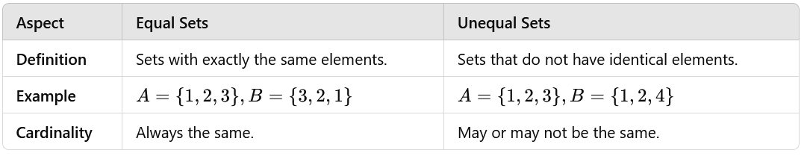

Unequal sets are fundamental in understanding differences between groups of items, whether in mathematics, data analysis, or real-world applications. Recognizing unequal sets helps in distinguishing variations and addressing inconsistencies.

Importance of Unequal Sets in Mathematics and Real Life
# Source: AI Source: Provided by: [Data Path: Persons Table -> ID Column: 1, Name_En Column: Motasem Essam] -> From: [ChatGPT] on [7/7/2026]
Unequal sets play a significant role in understanding differences and analyzing relationships between collections of items. Their importance can be highlighted in various contexts:

1. Comparison and Differentiation
- Mathematical Context:
  - Unequal sets help distinguish between collections of elements.
  - Example: Differentiating the prime numbers (A={2,3,5,7}) from odd numbers (B={1,3,5,7,9}).
- Real-Life Context:
  - Helps identify differences, such as comparing two inventories or task lists.

2. Data Analysis and Classification
- Unequal sets are used to analyze datasets and group differences.
- Example: Comparing survey results between two groups to identify distinct preferences.

3. Problem-Solving in Logic
- Unequal sets help identify missing or extra elements in logical or mathematical problems.
- Example: In geometry, comparing sets of sides to verify whether a triangle is equilateral or scalene.

4. Application in Set Operations
- Unequal sets are essential for operations like:
  - Union (A∪B): Combines elements of both sets.
  - Difference (A−B): Finds elements in one set but not the other.
  - Symmetric Difference (AΔB): Identifies elements exclusive to each set.

5. Real-Life Applications
- Inventory Management:
  - Identifying missing or extra items in stock.
  - Example: Comparing items in two warehouses.
- Attendance Records:
  - Unequal sets help identify students who missed a class compared to another group.
- Shopping Lists:
  - Comparing two lists to find missing or differing items.

6. Conflict Resolution
- Unequal sets highlight discrepancies in agreements or datasets.
- Example: Checking inconsistencies in a contract by comparing two versions.
7. Pattern Recognition and Error Detection
- In Mathematics: Identifying differences in sequences or series.
- In Technology: Detecting differences in data files or database records.

8. Planning and Organization
- Unequal sets help plan efficiently by identifying what is unique or missing between two scenarios.
- Example: Comparing project requirements to available resources.

The concept of unequal sets is crucial for identifying differences, ensuring completeness, and analyzing relationships between collections. Their applications span from theoretical mathematics to practical, real-world problem-solving in fields like business, science, and technology.

Sets Types in real life

1-Examples of Finite Sets in the Real World
# Source: AI Source: Provided by: [Data Path: Persons Table -> ID Column: 1, Name_En Column: Motasem Essam] -> From: [ChatGPT] on [7/7/2026]
1. Days of the Week
- {Monday, Tuesday, Wednesday, Thursday, Friday, Saturday, Sunday}
2. Planets in the Solar System
- {Mercury, Venus, Earth, Mars, Jupiter, Saturn, Uranus, Neptune}
3. Letters in the English Alphabet
- {A,B,C,…,Z} (26 elements).
4. Primary Colors
- {Red, Blue, Yellow}.
5. Coins in a Wallet
- If a wallet contains 555 coins: {1 EGP, 50 Piasters, 25 Piasters, 10 Piasters, 5 Piasters}.
6. Family Members in a Household
- E.g., {Father, Mother, Daughter, Son}.

7. Fingers on a Human Hand
- {Thumb, Index, Middle, Ring, Little}.
8. Countries in a Continent
- E.g., countries in Africa: {Egypt, Nigeria, Kenya, etc. (54 total)}.
9. Traffic Light Colors
- {Red, Yellow, Green}.
10. Months of the Year
- {January, February, ..., December}.

Characteristics of Finite Sets in the Real World
# Source: AI Source: Provided by: [Data Path: Persons Table -> ID Column: 1, Name_En Column: Motasem Essam] -> From: [ChatGPT] on [7/7/2026]
1. Limited Number of Elements
- The number of elements in a finite set is countable and does not go on indefinitely.
  - Example: {Monday, Tuesday, ..., Sunday}.
2. Clear Boundaries
- All elements can be explicitly listed or identified.
  - Example: The finite set of {Planets in the Solar System}.
3. Fixed Size
- The cardinality (size) of a finite set is fixed and known.
  - Example: The alphabet in English has 262626 elements.
4. Completeness
- A finite set contains no infinite or undefined elements, ensuring completeness in real-world contexts.
  - Example: {Traffic Light Colors: Red, Yellow, Green}.
5. Subset Property
- Any subset of a finite set is also finite.
  - Example: {Countries in Africa}.

6. Countable Elements
- The elements can be counted, either by enumeration or mathematical calculation.
  - Example: {Months of the Year}=12.
7. Applicability
- Finite sets are used in contexts with clear limits, such as days in a week, family members, or traffic signals.
8. No Infinite Repetition
- Elements in a finite set do not repeat infinitely.
  - Example: The set {Digits from 0 to 9}\{\text{Digits from 0 to 9}\}{Digits from 0 to 9} is finite and does not include repetitions.

Characteristics of finite sets in the real world:
- Limited Elements: The set has a countable, fixed number of elements.
- Clear Boundaries: All elements can be explicitly listed.
- Fixed Size: The cardinality (size) of the set is finite.
- Completeness: No infinite or undefined elements exist.
- Subset Property: Any subset is also finite.
- Countable: Elements can be enumerated or calculated.
- No Infinite Repetition: Elements do not repeat endlessly.
- Applicability: Used in real-world contexts with clear limits, like days or months.

Finite sets are practical and essential for describing real-world scenarios with defined and countable elements.

2-Examples of Infinite Set in the Real World
# Source: AI Source: Provided by: [Data Path: Persons Table -> ID Column: 1, Name_En Column: Motasem Essam] -> From: [ChatGPT] on [7/7/2026]
- Set of Natural Numbers:
  - {1,2,3,4,5,… }
  - The set of natural numbers (1, 2, 3, ...) is infinite because there is no end to the sequence. You can keep adding numbers indefinitely.
- Set of Points on a Line:
  - In geometry, the set of all points on a line or a line segment is infinite.
  - Even though a segment might be finite, a full line extends infinitely in both directions. The set of points along the line is infinite, as there are an infinite number of points between any two given points.
- Set of Real Numbers:
  - The set of real numbers R (which includes all rational and irrational numbers) is infinite.
  - For example, between any two real numbers, no matter how close they are, there is always another real number. Therefore, the set of real numbers is uncountably infinite.
- Set of Decimal Expansions:
  - Consider the set of all possible decimal expansions between 0 and 1. The number of such decimal representations is infinite, as you can always add more digits (e.g., 0.1, 0.01, 0.001, etc.).
  - This is another example of an infinite set, especially because the decimal expansions never end.
- Set of Stars in the Universe:
  - While we can't count every star in the universe, the set of stars can be considered infinite because, according to current scientific understanding, the universe is constantly expanding, and there is an infinite number of stars.
6. Locations on Earth
  - Infinite points on the surface of the Earth when considering infinitely precise coordinates.
7. Possibilities in Computer Programs
  - Infinite potential data input or output for algorithms designed to handle theoretical infinite streams.
Infinite sets describe systems or scenarios without limits, appearing frequently in mathematics and nature.

Characteristics of Infinite Sets in the Real World
# Source: AI Source: Provided by: [Data Path: Persons Table -> ID Column: 1, Name_En Column: Motasem Essam] -> From: [ChatGPT] on [7/7/2026]
1-Unlimited Elements: Infinite sets have an endless number of elements.
- Example: Natural numbers ({1,2,3,…}.
2-Uncountability: Some infinite sets, like real numbers, cannot be fully enumerated.
- Example: Real numbers between 0 and 1.
3-Subset Property: An infinite set can have subsets that are also infinite.
- Example: Integers (Z) and natural numbers (N).
4-Density: Elements in some infinite sets, like real numbers, are densely packed with no gaps.
- Example: Points on a line.
5-Extends Indefinitely: Infinite sets continue without end in one or more directions.
- Example: Time (past and future moments\text{past and future moments}past and future moments).
6-Includes Abstract Concepts: Often represent theoretical or idealized constructs.
- Example: Infinite decimal expansions (e.g., π\piπ).
7-Infinite Subdivisions: Between any two elements, infinite subdivisions may exist.
- Example: Rational numbers between 0 and 1.
8-Not Exhaustive: Impossible to list all elements explicitly.
- Example: The set of prime numbers.

These traits make infinite sets essential for modeling and understanding unbounded or continuous phenomena.

3-Examples of null set in the Real World
# Source: AI Source: Provided by: [Data Path: Persons Table -> ID Column: 1, Name_En Column: Motasem Essam] -> From: [ChatGPT] on [7/7/2026]
1. Set of even prime numbers greater than 2:
- There are no even prime numbers greater than 2 because the only even prime number is 2 itself.
- The set of even prime numbers greater than 2 is an empty set:
∅={}
2. Set of countries located both in Africa and Antarctica:
- No country exists that is located in both Africa and Antarctica. So, the set of countries in both continents is empty:
∅={}
3. Set of natural numbers less than 1:
- The set of natural numbers less than 1 is empty, because natural numbers start at 1, so there are no natural numbers smaller than 1.
∅={}

4. Students Absent in a Fully Attended Class
- ∅: The set of absent students when all are present.
∅={}

5-Set of apples in a basket that contains only bananas:
- If a basket contains only bananas and no apples, the set of apples in that basket is an empty set:
∅={}

6. Countries in Antarctica
- ∅: No countries exist in Antarctica.
7. Humans on Mars
- ∅: The set of humans currently living on Mars.
8. Solutions to Impossible Equations
- ∅: Solutions to x²+1=0 (over real numbers).
9. Squares with Five Sides
- ∅: The set of squares with five sides.

Key Characteristics of the Null (Empty) Set
# Source: AI Source: Provided by: [Data Path: Persons Table -> ID Column: 1, Name_En Column: Motasem Essam] -> From: [ChatGPT] on [7/7/2026]
1-No Elements: A null set contains no elements, representing situations where nothing satisfies a given condition.
- Example: The set of humans currently living on Mars.
2-Unique: The empty set is always the same, regardless of context.
- Denoted as ∅.
3-Subset of Every Set: The null set is a subset of any set, as it does not violate the subset definition.
- Example: ∅⊆{Planets}.
4-Zero Cardinality: The size (cardinality) of a null set is 0, as it has no elements.
- Example: The set of squares with five sides has 0 elements.
5-Unchanging: Adding or removing elements cannot apply to the empty set because it has no elements.

6-Logical Representation: Often used to describe situations where a search or condition yields no results.
- Example: Solutions to x²+1=0 over real numbers.
7-Indispensable in Mathematics: Serves as a foundational concept in set theory and logical reasoning.
- Example: Essential in defining power sets and subset relationships.
8-Abstract Yet Practical: Reflects real-world scenarios of impossibility or absence.
- Example: The set of people taller than 10 meters.

4-Examples of Singleton set in the Real World
# Source: AI Source: Provided by: [Data Path: Persons Table -> ID Column: 1, Name_En Column: Motasem Essam] -> From: [ChatGPT] on [7/7/2026]
Here are examples of singleton sets in the real world, where the set contains exactly one element:
1-Set of a Single Country:
- If we consider a set that contains only one country, like France: {France}
- This set is a singleton set because it contains only one country.
2-Set of a Specific Person:
- If we have a set that contains just one person, say "Alice": {Alice}
- This set is also a singleton set, containing just Alice.
3-Set of a Single Book:
- Consider a set that contains only one book, for example, "The Catcher in the Rye": {The Catcher in the Rye}
- This is a singleton set because it only contains that one book.
4-Set of a Specific Object:
- A set containing just a single object, like a red ball: {Red Ball}
- This is a singleton set, with only the red ball as its member.
5-Set of a Single Element in Mathematics:
- The set containing the number 5: {5}
- This is a singleton set, as it contains exactly one number, 5.
6-Personal Identity:
- The set of your national ID number: {Your ID}
7-Solar System:
- The set of Earth's moon: {Moon}.
8-Sports:
- The set containing the winner of a specific competition: {Winner}.
9-Geography:
- The set of the highest mountain in the world: {Mount Everest}.
10-Science:
- The set of the speed of light in a vacuum: {299,792,458 m/s}.
11-Mathematics:
- The set of the solution to the equation x²=0: {0}.
12-Library System:
- The set containing the only available copy of a specific rare book: {Rare Book}.
13-History:
- The set of the first president of a country (e.g., the USA): {George Washington}.

Singleton sets model scenarios involving unique entities or outcomes.

Key Points About Singleton Sets
# Source: AI Source: Provided by: [Data Path: Persons Table -> ID Column: 1, Name_En Column: Motasem Essam] -> From: [ChatGPT] on [7/7/2026]
Here are the characteristics of a null set (empty set) in the real world:
- No Elements: A null set represents the absence of elements satisfying a condition.
  - Example: The set of humans currently living on Mars.
- Zero Cardinality: The size of a null set is always 0 because it has no elements.
  - Example: The set of students taller than 10 meters.
- Subset of Every Set: The null set is a subset of any set, as it contains no elements to conflict with others.
  - Example: ∅⊆{Natural Numbers}.
- Universal Representation: The null set is the same in all contexts and is denoted as ∅ or {}.
- Occurs in Impossibilities: Often used to describe situations where a condition cannot be met.
  - Example: The set of square circles.
- Logical Consistency: Acts as the basis for defining power sets and subset relationships in mathematics.
  - Example: ∅ is part of the power set of any set.
- Unchanging Nature: The null set cannot gain or lose elements, as it starts empty.
- Practical Applications: Reflects real-world situations of absence or impossibility.
  - Example: The set of five-sided triangles.
The null set is essential for describing and understanding conditions of nonexistence or impossibility in both mathematical and real-world scenarios.

Mathematical and Practical Uses of Singleton Sets
# Source: AI Source: Provided by: [Data Path: Persons Table -> ID Column: 1, Name_En Column: Motasem Essam] -> From: [ChatGPT] on [7/7/2026]
- Mathematics: Singleton sets are often used to represent specific values or objects. For example, in topology, a point can be represented as a singleton set.
- Computer Science: In algorithms, singleton sets can represent simple cases, such as when a set needs to be initialized with one item or when dealing with unique items in databases.
- Logic: In logic and formal systems, singleton sets are used to define or refer to specific instances of objects or propositions.
A singleton set contains exactly one element, Examples in the real world could include sets like {France}, The cardinality of any singleton set is 1, It is a fundamental concept in set theory with practical applications in various fields like mathematics, computer science, and logic.

5-Examples of Power Set in the Real World
# Source: AI Source: Provided by: [Data Path: Persons Table -> ID Column: 1, Name_En Column: Motasem Essam] -> From: [ChatGPT] on [7/7/2026]
1. Days of the Week (Work Schedule Options)
Original Set: {Monday, Tuesday, Wednesday}
Power Set:
{∅,{Monday},{Tuesday},{Wednesday},{Monday, Tuesday},{Monday, Wednesday},{Tuesday, Wednesday},{Monday, Tuesday, Wednesday}}.
Use: Exploring combinations of work or rest days.

2. Menu Choices
Original Set: {Pizza, Salad}
Power Set:
{∅,{Pizza},{Salad},{Pizza, Salad}}.
Use: Determining all possible meal combinations.

3. Team Selection
Original Set: {Alice, Bob, Charlie}
Power Set:
Includes subsets like {Alice, Bob}, {Charlie}, and ∅.
Use: Listing all possible team combinations.

4. Security Access Levels
Original Set: {Read, Write, Execute}
Power Set:
Lists all combinations, including no permissions (∅) and full access ({Read, Write, Execute}).
Use: Defining file access permissions.

5. Travel Destinations
Original Set: {Paris, Rome, Tokyo}
Power Set:
Includes subsets like {Paris, Rome}, {Rome}, and {Paris, Rome, Tokyo}.
Use: Exploring all possible travel combinations.
6. Ingredients in a Recipe
Original Set: {Flour, Sugar}
Power Set:
{∅,{Flour},{Sugar},{Flour, Sugar}}.
Use: Listing all ingredient variations.

7. Lighting Options
Original Set: {Kitchen Light, Bedroom Light}
Power Set:
Includes combinations like {Kitchen Light}, {Bedroom Light}, and ∅.
Use: Controlling light configurations.
The power set concept is widely applicable in real-world scenarios involving combinations, permissions, and decision-making.

Key Points About Power Set
# Source: AI Source: Provided by: [Data Path: Persons Table -> ID Column: 1, Name_En Column: Motasem Essam] -> From: [ChatGPT] on [7/7/2026]
- Contains All Subsets: A power set includes every possible subset of the original set, including the empty set and the full set.
  - Example: For {Pizza, Salad}, the power set is {∅,{Pizza},{Salad},{Pizza, Salad}}.
- Exponential Growth: The size of the power set is 2^{n}, where n is the number of elements in the original set.
  - Example: A set of 3 elements {A, B, C}} has 2³=8 subsets.
- Includes the Empty Set: The power set always contains the null set (∅\emptyset∅), representing no selection.
  - Example: No selected travel destinations.
- Hierarchical Structure: The subsets range from the smallest (the empty set) to the largest (the original set itself).
  - Example: A team's combinations range from no members to all members.
- Practical Applicability: Power sets model real-world decision-making involving combinations or selections.
  - Example: Scheduling workdays or choosing ingredients for a recipe.
- Order Does Not Matter: Power sets are concerned with combinations, not the sequence of elements.
  - Example: {Pizza, Salad} is the same as {Salad, Pizza}.
- Completeness: A power set covers all possibilities, ensuring no subset is missed.
  - Example: All possible permissions in a file system ({Read, Write, Execute}.
- Abstract yet Practical: While theoretical in nature, power sets are used in planning, security, and analysis.
  - Example: Examining all lighting configurations in a building.
Power sets serve as a comprehensive framework for analyzing combinations and possibilities in diverse real-world contexts.

6-Examples of Universal Set in the Real World
# Source: AI Source: Provided by: [Data Path: Persons Table -> ID Column: 1, Name_En Column: Motasem Essam] -> From: [ChatGPT] on [7/7/2026]
Here are examples of universal sets in the real world, representing the "complete set" in a given context:
1. Students in a School
- Universal Set: U={All students in the school}.
Use: Sets of students in specific classes, clubs, or teams are subsets of this universal set.
2. Books in a Library
- Universal Set: U={All books in the library}.
Use: Sets of books by a particular author, genre, or section are subsets of this universal set.
3. Citizens of a Country
- Universal Set: U={All citizens of the country}.
Use: Subsets include those eligible to vote, specific age groups, or professions.
4. Animals in a Zoo
- Universal Set: U={All animals in the zoo}.
Use: Subsets include mammals, reptiles, or animals in specific enclosures.
5. Products in a Supermarket
- Universal Set: U={All products in the supermarket}.
Use: Subsets include dairy products, beverages, or items on sale.
6. Planets in the Solar System
- Universal Set: U={All planets in the solar system}.
Use: Subsets include terrestrial planets or gas giants.
7. Members of a Sports Team
- Universal Set: U={All registered players in the team}.
Use: Subsets include active players, reserves, or those playing a specific position.

8. Words in a Dictionary
- Universal Set: U={All words in the dictionary}.
Use: Subsets include verbs, nouns, or words starting with a specific letter.
9. Vehicles in a Parking Lot
- Universal Set: U={All vehicles in the parking lot}.
Use: Subsets include cars, motorcycles, or electric vehicles.
10. Employees in a Company
- Universal Set: U={All employees in the company}.
Use: Subsets include managers, interns, or employees in specific departments.
The universal set depends on the context and includes all possible elements relevant to that context, serving as the "complete" reference set.

Key Points About Universal Set
# Source: AI Source: Provided by: [Data Path: Persons Table -> ID Column: 1, Name_En Column: Motasem Essam] -> From: [ChatGPT] on [7/7/2026]
- Comprehensive: The universal set includes all elements relevant to a specific context or domain.
  - Example: All students in a school when considering subsets like classes or clubs.
- Context-Dependent: The contents of the universal set vary based on the scenario being studied.
  - Example: The universal set for a library includes all books, while for a zoo, it includes all animals.
- Superset of All Subsets: Every subset, including the empty set, is a part of the universal set.
  - Example: Fiction books or books by a specific author are subsets of the set of all library books.
- Finite or Infinite: The universal set can be finite (e.g., all employees in a company) or infinite (e.g., all real numbers).
  - Example: All integers form an infinite universal set in number theory.
- Inclusive of the Null Set: The null set (∅) is always a subset of the universal set.
  - Example: In a classroom setting, the absence of late students (∅) is still a valid subset.
- Unchanging for a Given Context: The universal set remains fixed as long as the context does not change.
  - Example: The universal set of planets in the solar system includes only the eight recognized planets.
- Basis for Complements: Complements of subsets are defined relative to the universal set.
  - Example: If U={all employees} and A={managers}, the complement of A is {non-managers}.
- Framework for Analysis: The universal set provides the "boundary" for analyzing subsets and relationships.
  - Example: All registered voters serve as the universal set for election analysis.
- Clear Scope: Clearly defines what is "included" in the system under consideration.
  - Example: All products in a supermarket form the universal set for categorizing items.
- Cannot Be Empty: The universal set must always contain elements, as it represents the entirety of a domain.
- Example: The universal set of animals in a zoo cannot be empty if the zoo is operational.

The universal set is essential for defining the scope of a problem or context, ensuring all subsets and relationships are analyzed within a complete framework.

7-Examples of Disjoint Sets in the Real World
# Source: AI Source: Provided by: [Data Path: Persons Table -> ID Column: 1, Name_En Column: Motasem Essam] -> From: [ChatGPT] on [7/7/2026]
Here are real-world scenarios that illustrate the concept of disjoint sets:

1. Academic Subjects
- A={Math Teachers}, B={Science Teachers}.
Explanation: A teacher cannot simultaneously teach both subjects in this context, making the sets disjoint.
2. Modes of Transportation
- A={Cars, Trucks, Buses}, B={Boats, Ships, Yachts}.
Explanation: Vehicles on land and water are distinct categories.

3. Sports Teams
- A={Team A’s Players}, B={Team B’s Players}.
Explanation: Players cannot belong to two competing teams simultaneously in a game.
4. Employees by Role
- A={Managers}, B={Interns}.
Explanation: An individual cannot be both a manager and an intern at the same time.

5. Categories of Animals
- A={Mammals}, B={Bird.
Explanation: Mammals and birds are separate biological classifications.

6. Library Book Genres
- A={Fiction Books}, B={Non-fiction Books}.
Explanation: A book cannot be classified as both fiction and non-fiction.

7. Customer Groups
- A={New Customers}, B={Returning Customers}.
Explanation: A customer cannot simultaneously belong to both groups.

8. Types of Numbers
- A={Odd Numbers}, B={Even Numbers}.
Explanation: A number cannot be both odd and even.

9. Types of Plants
- A={Flowering Plants}, B={Non-flowering Plants}.
Explanation: A plant cannot belong to both categories.
10. School Clubs
- A={Drama Club Members}, B={Science Club Members}.
Explanation: Membership is exclusive to each club.

In each case, the two sets do not overlap, making them disjoint. These examples demonstrate the utility of disjoint sets for organizing, classifying, and analyzing distinct groups in the

Key Points About Disjoint Sets
# Source: AI Source: Provided by: [Data Path: Persons Table -> ID Column: 1, Name_En Column: Motasem Essam] -> From: [ChatGPT] on [7/7/2026]
- No Overlap Between Sets
  - Disjoint sets have no elements in common.
  - Example: A={Cats}, B={Dogs}; no animal belongs to both sets.
- Mutually Exclusive
  - Membership in one set automatically excludes membership in another.
  - Example: A person cannot simultaneously be in A={Children} and B={Adults}.
- Intersection is Null
  - The intersection of disjoint sets is always the empty set (∅).
  - Example: The set of odd numbers and even numbers has no common elements.
- Distinct Classifications
  - Disjoint sets often represent distinct or mutually exclusive categories.
  - Example: A={Fiction Books}, B={Non-Fiction Books.
- Visually Non-Overlapping
  - In a Venn diagram, disjoint sets are shown as non-overlapping circles.
  - Example: Two disjoint circles representing students in different grades.
- Defined by Context
  - The definition of disjoint sets depends on the context in which the sets are being used.
  - Example: Employees categorized as A={Managers} and B={Interns}.
- Simplifies Classification
  - Disjoint sets help in organizing data into clear, separate categories.
  - Example: Sorting fruits into A={Citrus Fruits} and B={Berries}.
- Used in Logical Grouping
  - Disjoint sets are helpful in decision-making and planning where exclusive groups are required.
  - Example: Assigning workers to A={Day Shift} and B={Night Shift}.

- Supports Probability Calculations
  - Disjoint sets are fundamental in calculating probabilities for mutually exclusive events.
  - Example: Flipping a coin where A={Heads} and B={Tails}.
- Real-World Applicability
- Disjoint sets are used in practical scenarios like team assignments, role allocations, and resource distributions.
- Example: Separating A={Male Athletes} and B={Female Athletes}.

8-Examples of Equivalent Sets in Real Life
# Source: AI Source: Provided by: [Data Path: Persons Table -> ID Column: 1, Name_En Column: Motasem Essam] -> From: [ChatGPT] on [7/7/2026]
1-Classrooms:
- A={Boys in a class}, B={Girls in a class}} → Equivalent if both groups have the same number of students.
Bookshelves:
- A={Fiction books}, B={Non-fiction books} → Equivalent if both shelves hold the same number of books.
Sports Teams:
- A={Players on Team A}, B={Players on Team B} → Equivalent if both teams have the same number of players.
Tickets:
- A={Concert Tickets Sold}, B={Seats in the Concert Hall} → Equivalent if every ticket corresponds to one seat.
Vehicles:
- A={Cars in Parking Lot 1}}, B={Cars in Parking Lot 2} → Equivalent if both lots contain the same number of cars.

Key Points About Equivalent Sets
# Source: AI Source: Provided by: [Data Path: Persons Table -> ID Column: 1, Name_En Column: Motasem Essam] -> From: [ChatGPT] on [7/7/2026]
- Equal Number of Elements:
  - Equivalent sets always have the same number of items, even if the items themselves differ.
  - Example: A classroom has A={10 boys} and B={10 girls}, making A∼B.
- Unrelated Content:
  - The elements of equivalent sets can belong to entirely different categories.
  - Example: A={5 cars}, B={5 fruits}.
- No Overlap Required:
  - Elements do not have to be identical or shared between the sets.
  - Example: A={Monday, Tuesday}, B={Red, Blue}.
- Used for Comparison:
  - Equivalent sets are a practical way to compare the size of different groups or collections.
  - Example: Checking if there are enough seats (A) for all attendees (B) at a meeting.
- Applicable to Finite Sets:
  - In most real-world scenarios, equivalent sets involve finite groups of items.
  - Example: Matching A={10 parcels} with B={10 delivery vehicles}.
- One-to-One Correspondence:
  - Each element in one set can pair with exactly one element in the other set.
  - Example: Pairing A={5 employees} with B={5 tasks}.
- Visual Representation:
  - Equivalent sets are often depicted as groups of equal size in diagrams or tables.
  - Example: Pie charts showing equivalent numbers of males and females.
- Resource Allocation:
  - Ensures fair distribution when comparing two groups of the same size.
  - Example: Dividing A={10 sandwiches} among B={10 people}.
- Order Doesn’t Matter:
  - The arrangement or sequence of items in the sets is irrelevant.
  - Example: A={Apple, Banana}, B={Banana, Apple}.
- Logical Clarity:
  - Helps in simplifying real-life problems by focusing on quantity rather than content.
  - Example: Ensuring A={Number of invitations sent} matches B={Number of chairs arranged}.
These characteristics make equivalent sets a useful concept for organizing, comparing, and ensuring balance in everyday scenarios.

9-Examples of Equal Sets in Real Life
# Source: AI Source: Provided by: [Data Path: Persons Table -> ID Column: 1, Name_En Column: Motasem Essam] -> From: [ChatGPT] on [7/7/2026]
- Days of the Week:
  - A={Monday, Tuesday, Wednesday, Thursday, Friday, Saturday, Sunday}
  - B={Sunday, Saturday, Friday, Thursday, Wednesday, Tuesday, Monday}Both sets represent the same days, so A=B.
- Coins of a Specific Denomination:
  - A={1 Egyptian pound coin, 50 piasters}
  - B={50 piasters, 1 Egyptian pound coin}
  - Both sets contain the same coins.
- Classes on a Weekly Schedule:
  - A={Math, Physics, Chemistry}
  - B={Chemistry, Math, Physics}
  - If the classes are identical, the sets are equal.

- Fruits in Two Baskets:
  - A={Apple, Orange, Banana}
  - B={Banana, Orange, Apple}
  - The two baskets contain the same types of fruits.
- Team Roster:
  - A={John, Ali, Mary}
  - B={Mary, Ali, John}
  - Both sets represent the same team members.
- Shopping List:
  - A={Milk, Bread, Eggs}
  - B={Eggs, Bread, Milk}
  - The shopping lists are identical in items.
- Books in Two Shelves:
  - A={Harry Potter, The Hobbit, Pride and Prejudice}
  - B={The Hobbit, Pride and Prejudice, Harry Potter}
  - Both shelves contain the same books.
- Set of Exam Topics:
  - A={Algebra, Geometry, Calculus}
  - B={Calculus, Geometry, Algebra}
  - The topics covered are identical.
- Color Choices:
  - A={Red, Blue, Green}
  - B={Green, Blue, Red}
  - Both sets represent the same colors.
- Attendees in Two Meeting Lists:
  - A={Sara, Ahmed, Omar}
  - B={Omar, Ahmed, Sara}
  - Both lists contain the same people.
Key Notes:
- In all these examples, the order of elements doesn't matter, as long as the content of the sets is identical.
- The concept of equal sets helps verify and validate equivalence in real-world scenarios.

Key Points About Equal Sets
# Source: AI Source: Provided by: [Data Path: Persons Table -> ID Column: 1, Name_En Column: Motasem Essam] -> From: [ChatGPT] on [7/7/2026]
1-Definition:
- Equal sets have exactly the same elements, irrespective of their order or repetition.
- Notation: A=B.
2-Identical Elements:
- All elements in set A must be present in set B, and vice versa.
- Example: A={1,2,3},B={3,2,1}.
3-Order Doesn't Matter:
- The arrangement of elements in the sets is irrelevant for equality.
- Example: A={Red, Blue},B={Blue, Red}.
4-Repetition is Ignored:
- Repeated elements do not affect the equality of sets.
- Example: A={1,1,2},B={1,2}.
5-Subset Rule:
- For sets to be equal, A⊆B and B⊆A must hold true.
6-Finite and Infinite Sets:
- Equal sets can be finite or infinite as long as their elements match exactly.
- Example: A={all even integers},B={all multiples of 2}.
7-Practical Verification:
- Comparing sets involves checking all elements in one set against the other.
8-Used in Real-Life Contexts:
- Useful for comparing datasets, verifying identical collections, or ensuring consistency.
9-Mathematical Significance:
- Equal sets are foundational in set theory, used in proofs and logical reasoning.
10-Difference from Equivalent Sets:
- Equal sets must have identical elements. Equivalent sets only need the same number of elements.
Importance:
The concept of equal sets ensures precision when comparing or validating collections of items, making it applicable in mathematics, computer science, data management, and real-world problem-solving.

10-Examples of Unequal Sets in Real Life
# Source: AI Source: Provided by: [Data Path: Persons Table -> ID Column: 1, Name_En Column: Motasem Essam] -> From: [ChatGPT] on [7/7/2026]
- Shopping Lists:
  - List A: {Milk, Bread, Eggs}
  - List B: {Milk, Bread, Butter}
  - The sets are unequal because Eggs≠Butter.
- Sports Teams Players:
  - Team A: {John, Sara, Omar, Ahmed}
  - Team B: {John, Sara, Omar, Lina}
  - The teams differ due to Ahmed and Lina.
- Class Attendance:
  - Day 1 Attendance: {Ali, Dina, Rami}
  - Day 2 Attendance: {Ali, Dina, Nada}
  - The sets are unequal as Rami≠Nada.
- Books in Libraries:
  - Library A: {Book1, Book2, Book3}
  - Library B: {Book1, Book3, Book4}
  - The libraries differ in Book2 and Book4.
- Fruit in Baskets:
  - Basket A: {Apple, Banana, Orange}
  - Basket B: {Apple, Orange, Mango}
  - The sets are unequal due to Banana≠Mango
- Vehicles in Parking Lots:
  - Lot A: {Car, Bike, Bus}
  - Lot B: {Car, Bike, Truck}
  - The difference is Bus≠Truck.
- Weekly Class Schedules:
  - Monday Schedule: {Math, English, History}
  - Tuesday Schedule: {Math, English, Chemistry}
  - The subjects differ as History≠Chemistry
- Exam Topics:
  - Subject A Topics: {Algebra, Geometry, Calculus}
  - Subject B Topics: {Algebra, Geometry, Statistics}
  - The sets are unequal due to Calculus≠Statistics
- Employee Lists:
  - Branch A: {Ahmed, Sara, Mona}
  - Branch B: {Ahmed, Sara, Omar}
  - The difference is Mona≠Omar.
- Color Palettes:
  - Palette A: {Red, Blue, Green}
  - Palette B: {Red, Blue, Yellow}
  - The sets are unequal due to Green≠Yellow.

Key Insight:
These examples illustrate how unequal sets arise in everyday scenarios when two collections of items differ in their elements. Recognizing these differences can help in tasks like comparison, validation, and planning.

Key Points About Unequal Sets
# Source: AI Source: Provided by: [Data Path: Persons Table -> ID Column: 1, Name_En Column: Motasem Essam] -> From: [ChatGPT] on [7/7/2026]
1-Definition:
- Two sets in real life are unequal when they do not contain exactly the same elements.
- This helps to distinguish differences between collections, inventories, or lists.
2-Comparison Tool:
- Unequal sets allow comparisons to identify differences in items, such as mismatched shopping lists or attendance records.
3-Real-World Examples:
- Comparing student groups for extracurricular activities.
- Identifying differences between two versions of a document.
- Checking mismatched items in inventories of different warehouses.
4-Error Detection:
- Unequal sets highlight discrepancies or missing items in practical tasks like project planning or stock management.
5-Time-Saving:
- Helps to quickly spot variations without checking every element manually, saving time in organizing or managing resources.
6-Basis for Data Analysis:
- Unequal sets are used in analyzing preferences or behaviors, such as comparing survey results across groups.
7-Resource Allocation:
- Identifies gaps or overlaps in resource distribution by comparing the needs of different departments or projects.

8-Conflict Resolution:
- Highlights inconsistencies in agreements or shared tasks, helping resolve disputes effectively.
9-Dynamic Nature:
- Real-life unequal sets often change over time, reflecting updates in inventory, schedules, or preferences.
10-Practical Utility:
- Found in diverse contexts like:
  - Education: Comparing exam topics across courses.
  - Business: Spotting product differences between competitors.
  - Event Planning: Checking discrepancies in guest lists.

Questions

Question 1
# Source: AI Source: Provided by: [Data Path: Persons Table -> ID Column: 1, Name_En Column: Motasem Essam] -> From: [ChatGPT] on [7/7/2026]
how Use The empty set plays an important role in mathematics as a starting point for set operations, such as unions, intersections, and differences.
The empty set (denoted as ∅) plays a fundamental role in set theory and mathematics in general. It is the set that contains no elements, and while it might seem trivial at first glance, it is crucial in many areas of mathematics, especially when working with set operations like unions, intersections, and differences.
Here’s a breakdown of how the empty set interacts with these operations:
1. Union with the Empty Set:
If A={1,2,3}, then: A∪∅={1,2,3}

Why is this important?
- The empty set acts like an identity element for union, similar to how 0 acts as the identity for addition in arithmetic. It does not affect the result of the union operation.

2. Intersection with the Empty Set:
If A={1,2,3} then: A∩∅=∅
Why is this important?
- The empty set is the absorbing element for intersection. No element in A can be in both A and ∅, because ∅ has no elements. This makes the intersection always result in the empty set.

3. Difference with the Empty Set:
If A={1,2,3}, then: A−∅={1,2,3}
Why is this important?
- The empty set behaves like an identity element for the difference operation as well. Subtracting nothing from a set leaves the set unchanged.

4. Set Difference with the Empty Set:
If A={1,2,3}, then: ∅−A=∅
Why is this important?
- This reflects the idea that there's nothing in the empty set to subtract. No matter what you try to remove from the empty set, the result is still empty.
5. The Empty Set as a Subset:
If A={1,2,3}, then: ∅⊆A
Why is this important?
- This is a fundamental property in set theory. It ensures that the empty set is compatible with all sets and simplifies the formulation of mathematical proofs and definitions.
6. The Role in Power Sets:
If A={1,2}, then: P(A)={∅,{1},{2},{1,2}}
Why is this important?
- The empty set is a natural starting point in the definition of the power set and sets in general. It is the smallest possible subset of any set and serves as the basis for building up all other subsets.

Summary: Why the Empty Set is Crucial
- Identity in Union: A∪∅=A
- Absorbing Element in Intersection: A∩∅=∅
- Identity in Set Difference: A−∅=A
- Subset of Every Set: ∅⊆A
- Included in the Power Set: The empty set is always part of any set’s power set.
The empty set acts as a fundamental building block in set theory, providing a neutral element for many set operations. It plays an essential role in mathematical logic, proofs, and the structure of set theory itself.

Question 2
# Source: AI Source: Provided by: [Data Path: Persons Table -> ID Column: 1, Name_En Column: Motasem Essam] -> From: [ChatGPT] on [7/7/2026]
why q is Countably Infinite Set and R is Uncountably Infinite Set

The distinction between Q= (the set of rational numbers) being countably infinite and R (the set of real numbers) being uncountably infinite arises from their different structures and the types of numbers they contain. Here's the reasoning:

1. Why Q is Countably Infinite
- A set is countable if its elements can be put into a one-to-one correspondence with the natural numbers N= (i.e., there exists a way to enumerate them as a₁,a₂,a₃,…).
- Rational numbers are numbers of the form p/q, where p and q are integers, and q≠0.
- To show Q\mathbb{Q}Q is countable:
  - List all pairs of integers (p,q) with q>0 (ignoring fractions that reduce to the same value, like 2/4 and 1/2​).
  - Arrange these pairs into a grid, with p along one axis and q along the other.
  - Use a diagonal argument to traverse the grid systematically, covering every rational number.
Despite Q being infinite, we can list all its elements in a sequence q₁,q₂,q₃,…, proving Q is countable.

2. Why R is Uncountably Infinite
- The set R contains all real numbers, including both rational numbers and irrational numbers (like sqrt{2})
- To show R is uncountable:
  - Use Cantor's diagonalization argument:
    - Assume R (e.g., the real numbers in [0,1]) is countable, and all its elements can be listed as r₁,r₂,r₃,…
    - Write each number in its decimal expansion (avoiding ambiguous cases like 0.4999… vs 0.5000
    - Construct a new number x by altering the n-th digit of r_{n} (e.g., change 5 to 6, or any other digit).
    - The number x differs from every r_{n} in at least one decimal place, meaning x is not in the list.
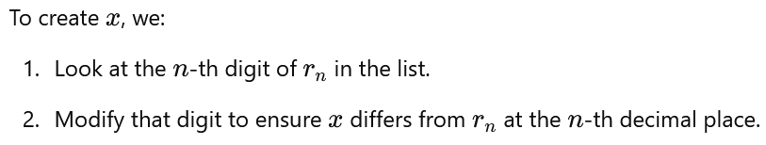
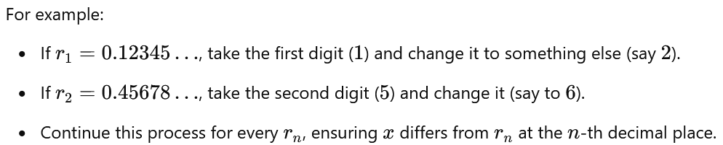
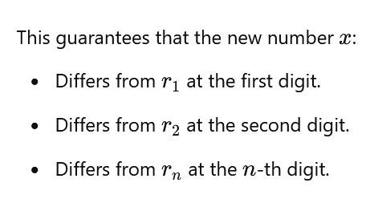
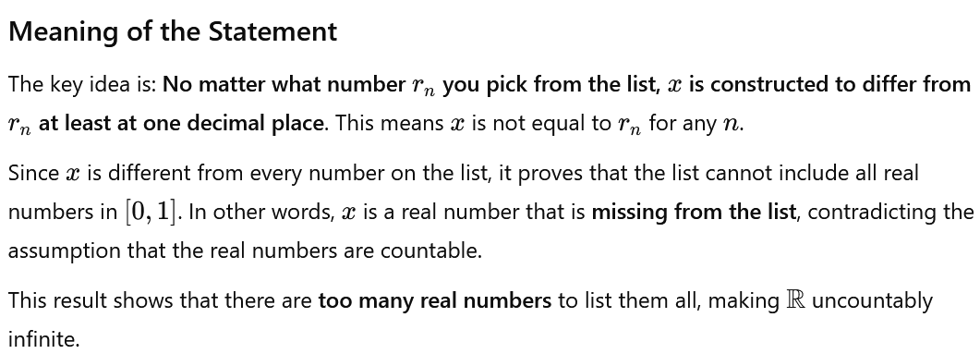

  - This contradiction shows R cannot be listed or enumerated, making it uncountable.

Cantor's diagonal argument works on R contains infinitely more numbers than Q—it includes all rational numbers and all irrational numbers. Here's the crucial distinction:

Rational Numbers
- Every rational number has a finite or repeating decimal expansion (e.g., 1/2=0.5, 1/3=0.333).
- Because of this, rational numbers can be fully enumerated and listed systematically, even if the list is very long.

Real Numbers
- Real numbers include not only rationals but also irrationals like π, sqrt{2}, e, etc.
- Irrational numbers have non-repeating, infinite decimal expansions, which cannot be listed in a sequence.
- The diagonal argument constructs a new number x that is different from every number in the supposed list of real numbers. Since Q doesn't include irrationals, it doesn't have this issue.
In Q, every number is already included in the systematic enumeration. There’s no “extra” number that you can construct using a diagonal argument that isn’t already in the list. But in R, the set of irrationals ensures there are always numbers missing from any list you attempt to create.

Summary of Key Differences
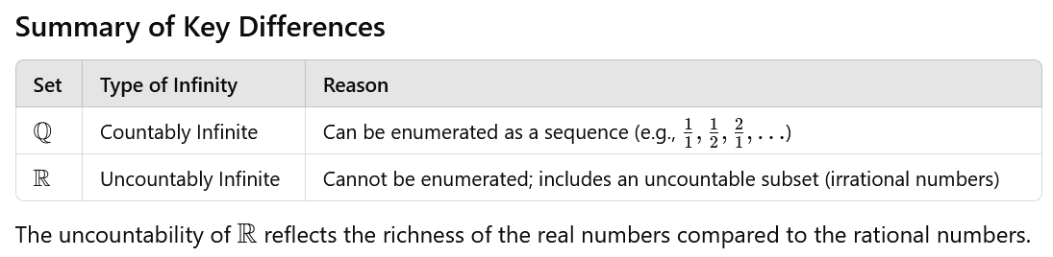

Academic Source: First primary - First term - Unit 1: Unit Two: Sets

Lesson Four: Types of sets
# Source: Academic source: Provided by: [Data Path: Persons Table -> ID Column: 1, Name_En Column: Motasem Essam] -> From: [Data Path: Sources Table -> ID Column: 351, Content Title Column: Math - Fifth Primary - First Semester] -> at: [Document, page: 56:57] on [7/7/2026]
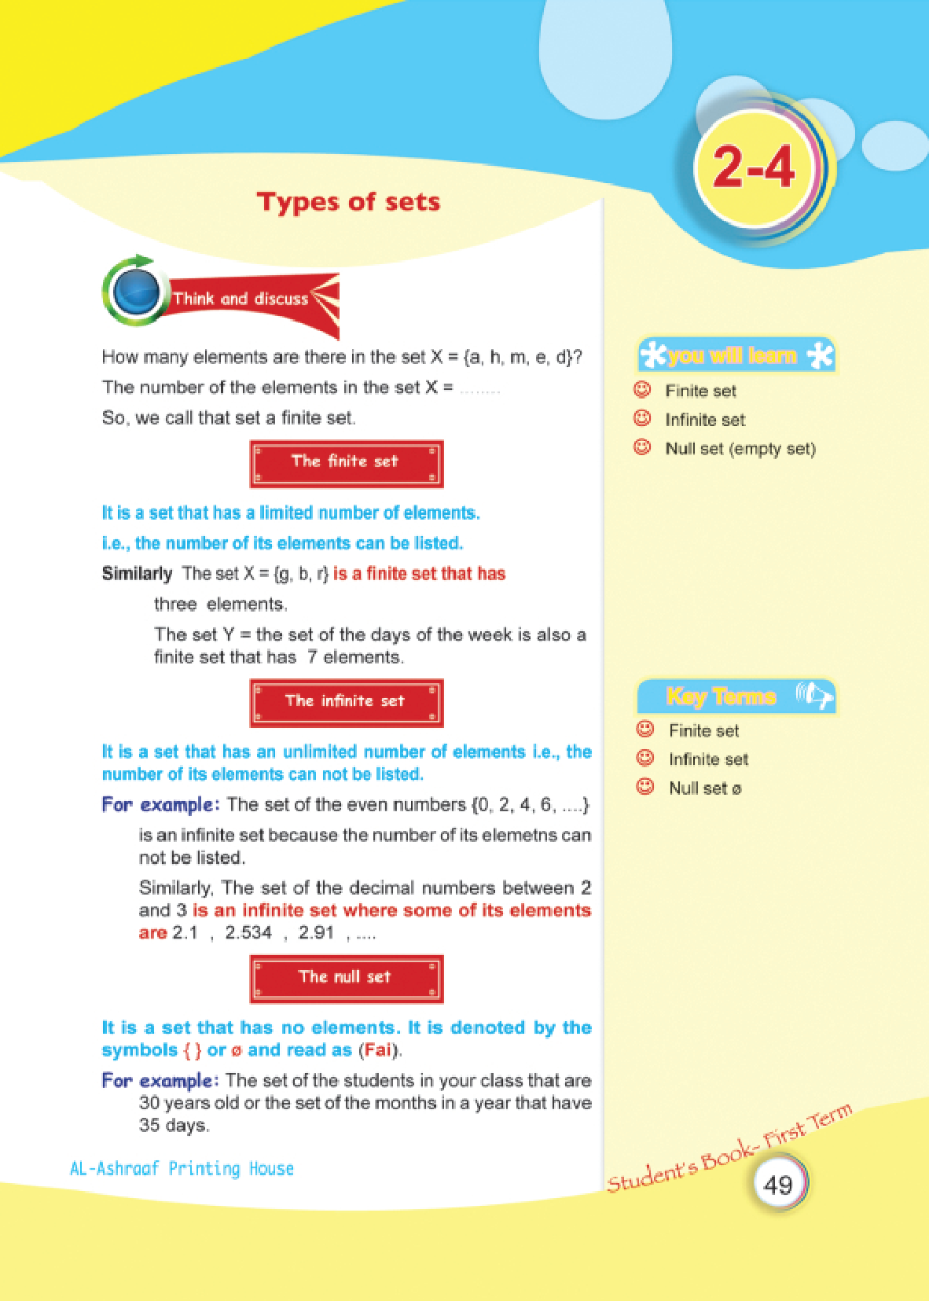
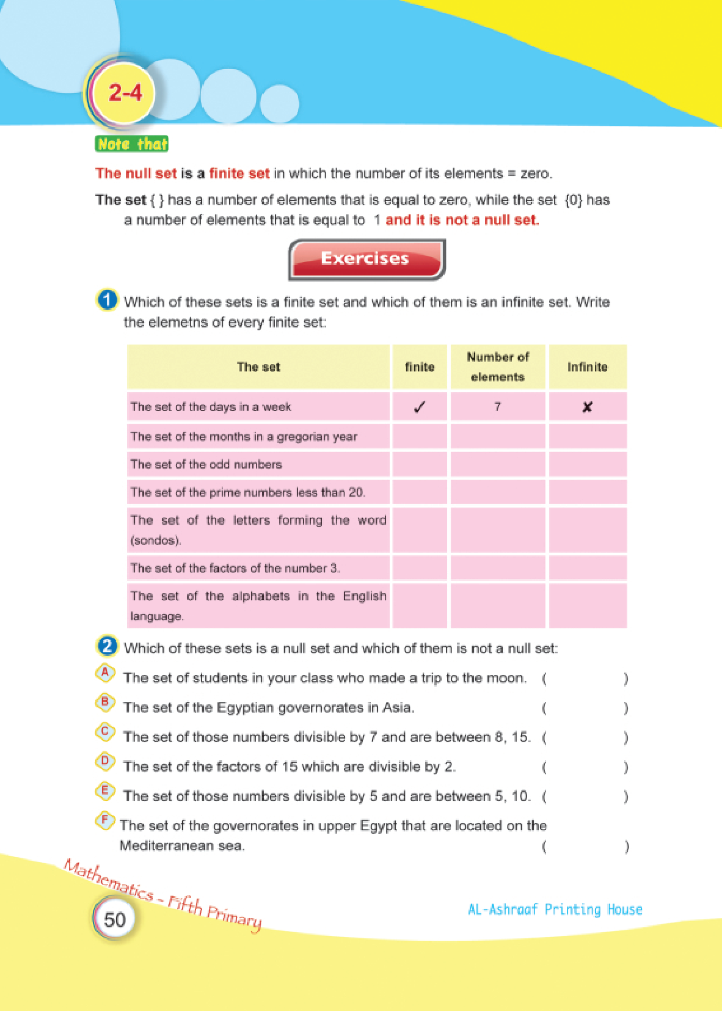

Lesson Five: Equal sets
# Source: Academic source: Provided by: [Data Path: Persons Table -> ID Column: 1, Name_En Column: Motasem Essam] -> From: [Data Path: Sources Table -> ID Column: 351, Content Title Column: Math - Fifth Primary - First Semester] -> at: [Document, page: 58:59] on [7/7/2026]
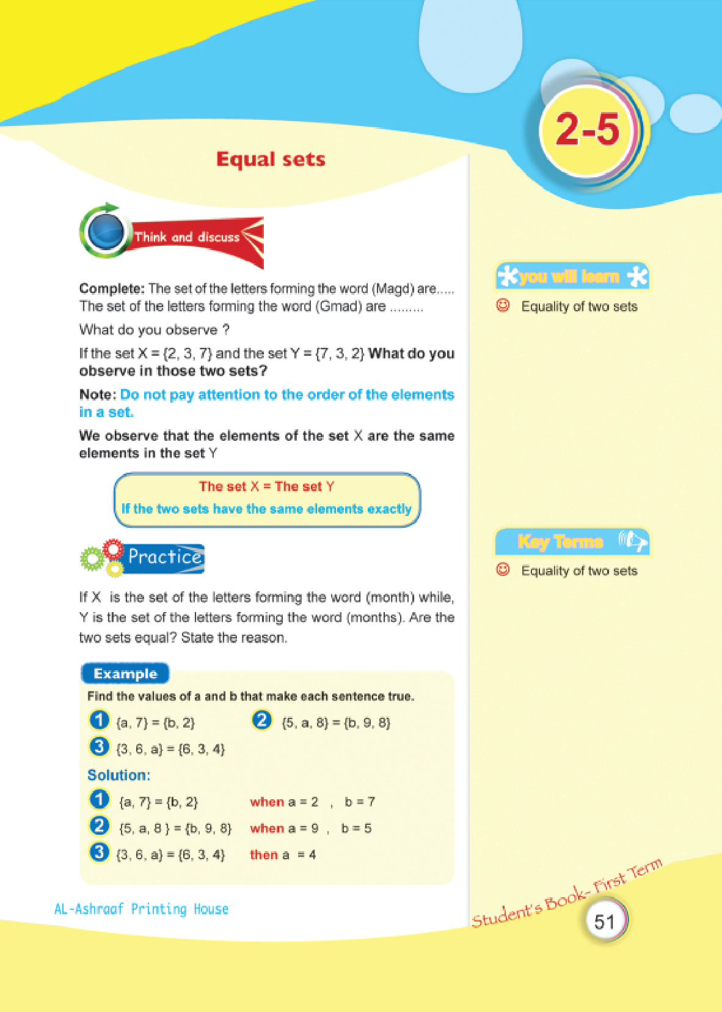
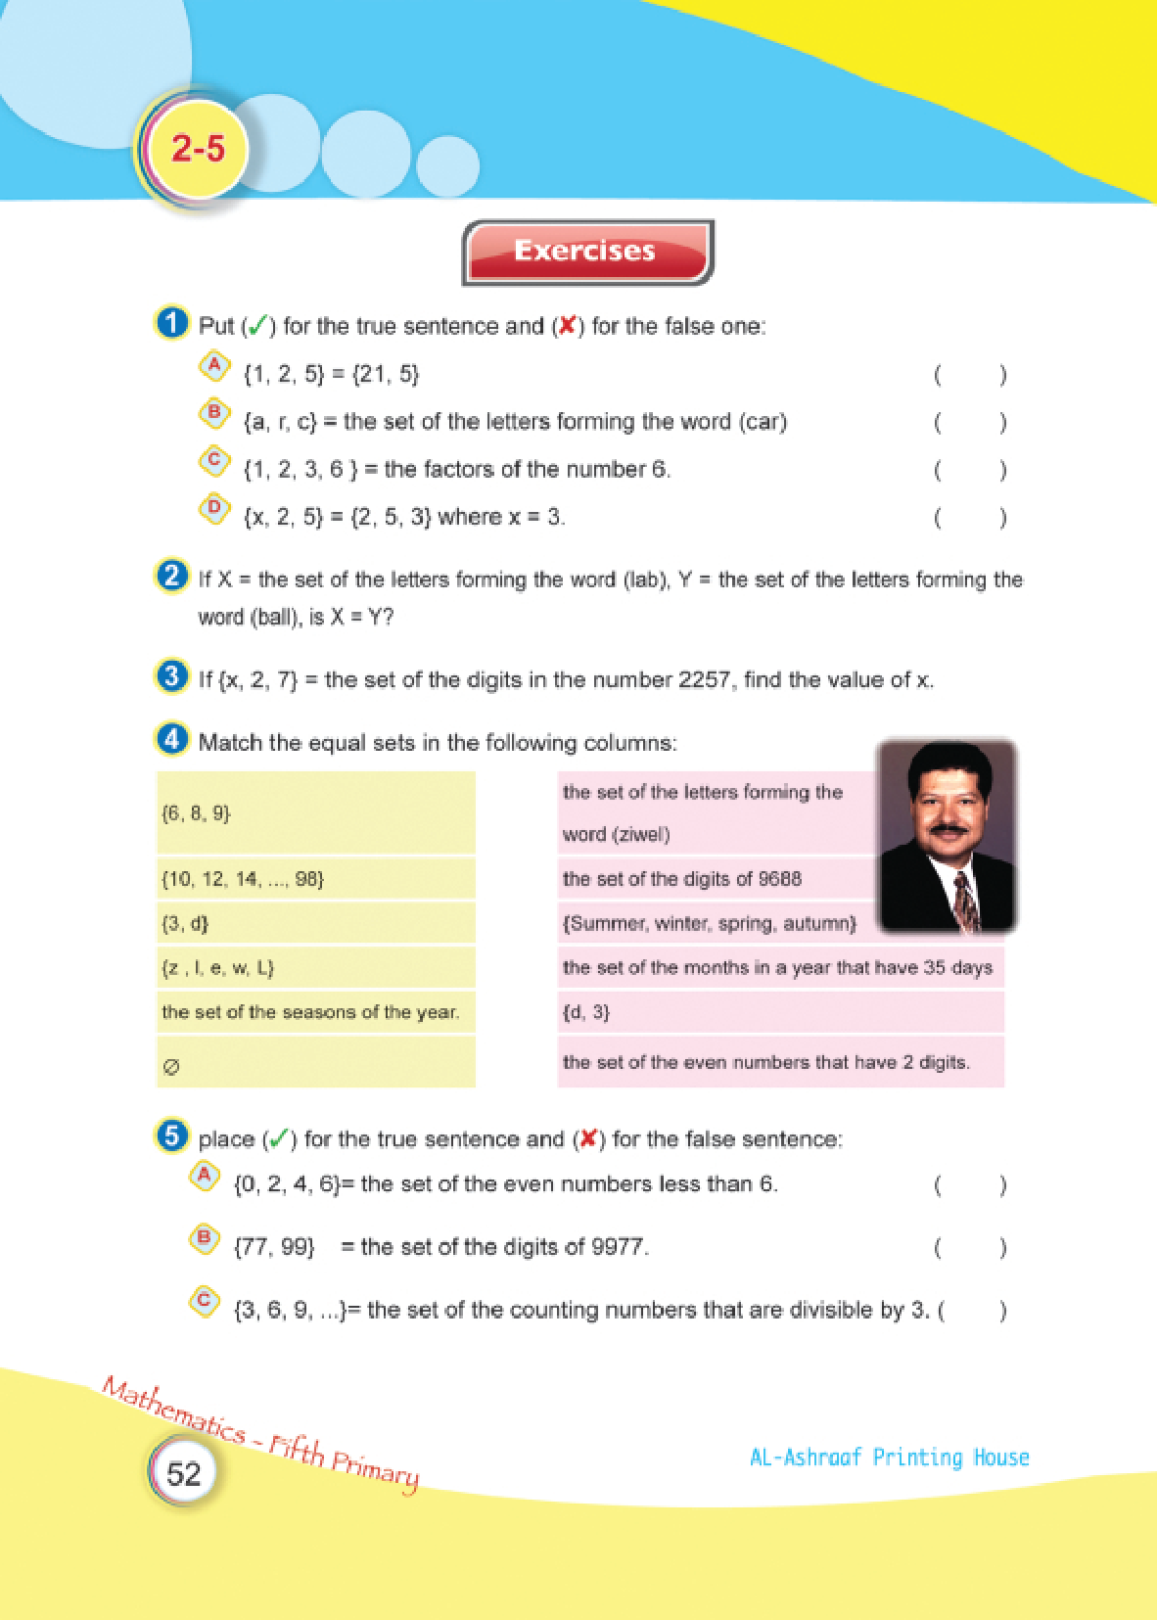

Lesson Nine: The universal set
# Source: Academic source: Provided by: [Data Path: Persons Table -> ID Column: 1, Name_En Column: Motasem Essam] -> From: [Data Path: Sources Table -> ID Column: 351, Content Title Column: Math - Fifth Primary - First Semester] -> at: [Document, page: 68:69] on [7/7/2026]


